**Supplementary**

**Supplementary methods**

**Figure S1-**The overall network architecture for our fusion model proposed.

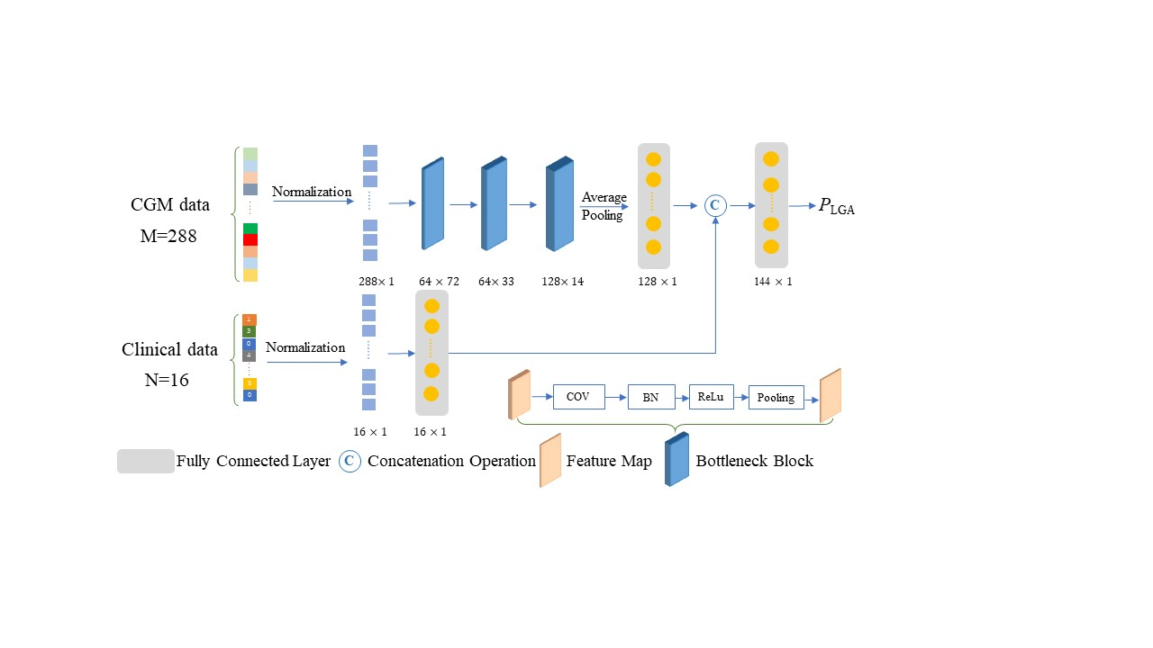

The entire fusion network is composed of two branches (CNN-based model and MLP-based model) to extract two streams of features. (1) The CGM data of each case with size of 288*1 is normalized into the feature tensor (vector). We further extract features by 1d convolution layer with kernel size of 7 and obtain feature tensor with size of 6472. Next, the feature tensor is fed into two convolution layer with kernel size of 5 and obtain feature tensor 12814. The max pooling operation is utilized to generate CGM data feature with size of 1281. (2) The clinical data is also first processed using normalization for each case. We extract feature using MLP to obtain feature tensor with size of 161. Two branches of feature tensors are fused via the concatenate operation to generate the fusion feature with size of 1441. The fusion feature tensor is utilized to predict the LGA with a final convolution layer.

**Loss function**

In our study, the positive samples account for about 20% of the entire dataset. Generally, the unbalanced sample distribution biases the network model towards negative samples, which results in the low prediction accuracy for positive samples. We have conducted experimented with the standard Binary Cross-Entropy loss[1] to optimize the prediction model:

(1)

**Experiment Setup**

We adopted the Adam solver to optimize the model for 20 epochs with a batch size of 16. The initial learning rate is set to 0.004, which decays with a factor of 10 for every 5 epochs. Our method is implemented using PyTorch, and all the experiments were conducted on a NVIDIA Geforce RTX 3090 GPU. We also performed a series of ablation studies to verify the contribution of each module. Specifically, the two branches are individually trained to predict the LGA under the same experimental setup. We evaluated and compared the performance of several methods, including random forest[2], decision tree[3], and logistic regression, using AUCROC and accuracy.

**Visualization analysis**

To visualize further the effectiveness of the proposed model, we calculate the weighted heatmap[4] from convolutional layers output in first branch via implementing the multiplication of features with 12814 dimensions and fully connected layer weights. We obtain the 232 feature-tensor with non-LGA and 62 features with LGA from the training dataset based on the trained CGM model. The two groups of heatmaps are presented in **Fig.S4 (A)** and **Fig.S4 (B)**, respectively. Comparing two cohorts, the feature values have significant differences via using color bar values. Additionally, we calculate the mean values of all feature tensors from two cohorts, and obtain **Fig.S4(C)**. The two curves show that the prediction model proposed have the ability to distinguish the LGA and non-LGA. Finally, we normalize the single feature tensor from training dataset, and obtain the mean curves of feature tensors as shown in **Fig.S4(D)**. The values of the feature tensor after the normalization operation represent the importance of corresponding feature values. This figure shows that the GDM data from 24h have different importance for predicting LGA cohorts and non-LGA ones.

**Supplementary results**

**Table S1-** Patients’ characteristics of training, validation and test datasets

|  |  |  |  |  |  |
| --- | --- | --- | --- | --- | --- |
| Characteristics | Total | Training Dataset | Validation Dataset | Test Dataset | *P*-value |
| N | 371 | 293 (79.0%) | 33 (8.9%) | 45 (12.1%) |  |
| Age (years) | 31.8±4.5 | 31.7±4.5 | 33.2±4.1 | 31.6±5.2 | 0.172 |
| Pregestational BMI (kg/m2) | 23.4±3.6 | 23.4±3.7 | 23.0±2.7 | 23.6±3.6 | 0.765 |
| BMI < 25 | 266(71.7) | 212(72.4) | 24(72.7) | 30(66.7) | 0.726 |
| BMI ≥ 25 | 105(28.3) | 33(27.6) | 33(27.3) | 72(33.3) |  |
| Height(cm) | 160±5 | 160±5 | 160±4 | 161±5 | 0.954 |
| GDM History (%) | 31(8.4) | 23(7.8) | 3(6.1) | 6(13.3) | 0.378 |
| Macrosomia History* (%) | 12(3.3) | 7(2.4) | 1(3.0) | 4(8.9) | 0.068 |
| Parity [n (%)] |  |  |  |  | 0.954 |
| 0 | 181(48.8) | 144(49.1) | 16(48.5) | 21(46.7) |  |
| ≥1 | 190(51.2) | 149(50.9) | 17(51.5) | 24(53.3) |  |
| Measurements in second trimester |  |  |  |  |  |
| Systolic Pressure (mmHg) | 116±10 | 116±10 | 114±10 | 115±10 | 0.334 |
| Diastolic Pressure (mmHg) | 71±9 | 71±9 | 70±10 | 70±7 | 0.611 |
| Maternal Weight Gain (Kg) | 7.4±4.6 | 7.4±4.6 | 8.2±4.3 | 6.8±4.9 | 0.410 |
| FPG (mmol/L) | 5.0±0.6 | 5.0±0.6 | 4.8±0.6 | 5.0±0.7 | 0.253 |
| OGTT 1h Glucose (mmol/L) | 10.2±1.7 | 10.2±1.8 | 10.2±1.2 | 10.1±1.5 | 0.904 |
| OGTT 2h Glucose (mmol/L) | 8.5±1.6 | 8.5±1.6 | 8.4±1.8 | 8.3±1.6 | 0.665 |
| HbA1c (%) | 5.2±0.4 | 5.2±0.4 | 5.2±0.5 | 5.1±0.4 | 0.662 |
| Fasting Insulin (μIU/L) | 62.0(45.4,87.5) | 60.7(45.8,88.6) | 66.0(37.4,81.0) | 67.4(44.1,90.8) | 0.175 |
| Cholesterol (mmol/L) | 5.8±1.1 | 5.8±1.1 | 5.9±0.9 | 5.9±1.1 | 0.596 |
| Triglycerides (mmol/L) | 2.6±1.0 | 2.6±1.1 | 2.4±0.7 | 2.7±1.1 | 0.589 |
| HDL (mmol/L) | 1.9±0.7 | 1.9±0.8 | 1.8±0.3 | 1.9±0.4 | 0.968 |
| LDL (mmol/L) | 3.0±0.9 | 3.0±0.9 | 3.1±0.9 | 3.0±0.9 | 0.660 |
| Glycated Albumin (%) | 12.9(11.9, 14.0) | 12.9(11.8,14.0) | 13.1(12.4,14.2) | 13.0(11.8,14.0) | 0.982 |
| 1h Insulin (μIU/L) | 425.8(298.2,630.0) | 430.0(305.6,644.4) | 421.7(278.8,577.5) | 390.6(302.0,739.0) | 0.929 |
| 2h Insulin (μIU/L) | 415.5(267.9,662.7) | 434.0(274.0,688.7) | 350.6(177.7,670.1) | 368.8(260.8,520.1) | 0.048 |
| CGM examine time (weeks) | 26.6(25.4-28.3) | 26.5(26.1-26.7) | 26.1(25.3-28.0) | 26.7(26.2-28.3) | 0.974 |
| Treatments after CGM |  |  |  |  | 0.561 |
| Medical treatment | 77(20.8) | 59(20.1) | 6(18.2) | 12(26.7) |  |
| Diet-exercise treatment | 294(79.2) | 234(79.9) | 27(81.8) | 33(73.3) |  |
| Maternal and neonatal outcomes |  |  |  |  |  |
| Delivery gestation time (weeks)* | 38(37,39) | 38(37,39) | 39(37,39) | 39(38,39) | 0.420 |
| Birth Weight(g) | 3217.8±527.7 | 3225.6±530.0 | 3109.4±571.6 | 3246.6±479.2 | 0.453 |
| LGA (%) |  |  |  |  | 0.991 |
| Yes | 76 (20.5) | 60 (20.5) | 7 (21.2) | 9 (20.0) |  |
| No | 295 (79.5) | 233 (79.5) | 26 (78.8) | 36 (80.0) |  |

Abbreviations: BMI, body mass index; CGM, continuous glucose monitoring; GDM, gestational diabetes mellitus; LGA, large for gestational age; OGTT, oral glucose tolerance test; SD, standard deviation.

**Table S2** Comparisons of variables values with missing data before and after multiple imputation

|  |  |  |  |  |
| --- | --- | --- | --- | --- |
| Variable | Missing size | Before | After | *P*-value |
| Mean (SD) | Mean (SD) |
| SBP | 1 | 116.10(10.57) | 116.13(10.33) | 0.9681 |
| DBP | 1 | 70.49(9.13) | 70.72(8.73) | 0.7418 |
| Cholesterol | 35 | 5.81(1.07) | 5.83(1.04) | 0.8050 |
| TG | 35 | 2.61(1.06) | 2.59(1.01) | 0.7594 |
| OGTT 1h | 16 | 10.15(1.70) | 10.19(1.71) | 0.7901 |
| HbA1c | 26 | 5.16(0.44) | 5.17(0.43) | 0.8070 |

Abbreviations: DBP, diastolic blood pressure; OGTT, oral glucose tolerance test; SBP, systolic blood pressure; SD, standard deviation; TG, triglyceride.

**Figure S2**- **24-h mean glucose profiles in LGA and non-LGA GDM pregnancies.**

(A) GDM women with BMI < 25 kg/m2; (B) GDM women with BMI 25 kg/m2; (C) Diet-treated GDM; (D) Medically-treated GDM; (E) in 2nd trimester; (F) in 3rd trimester.

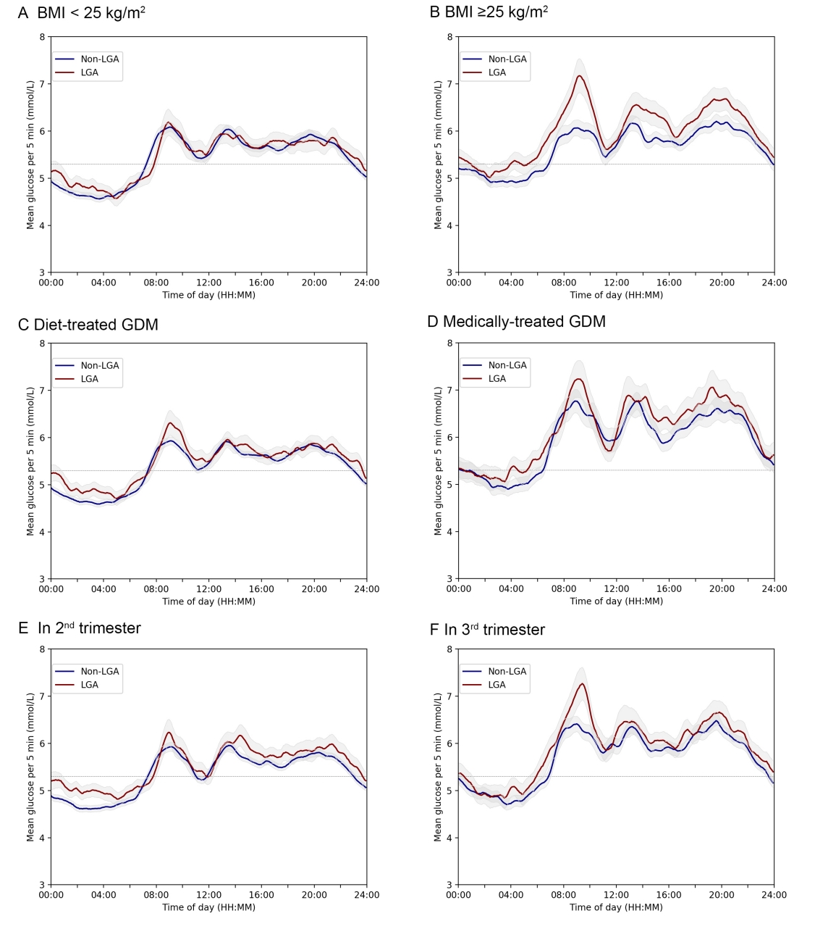

**Figure S3** Mean glucose difference profile of GDM with and without LGA infants. (A) GDM women with BMI < 25 kg/m2; (B) GDM women with BMI 25 kg/m2; (C) Diet-treated GDM; (D) Medically-treated GDM; (E) In 2nd trimester; (F) In 3rd trimester.

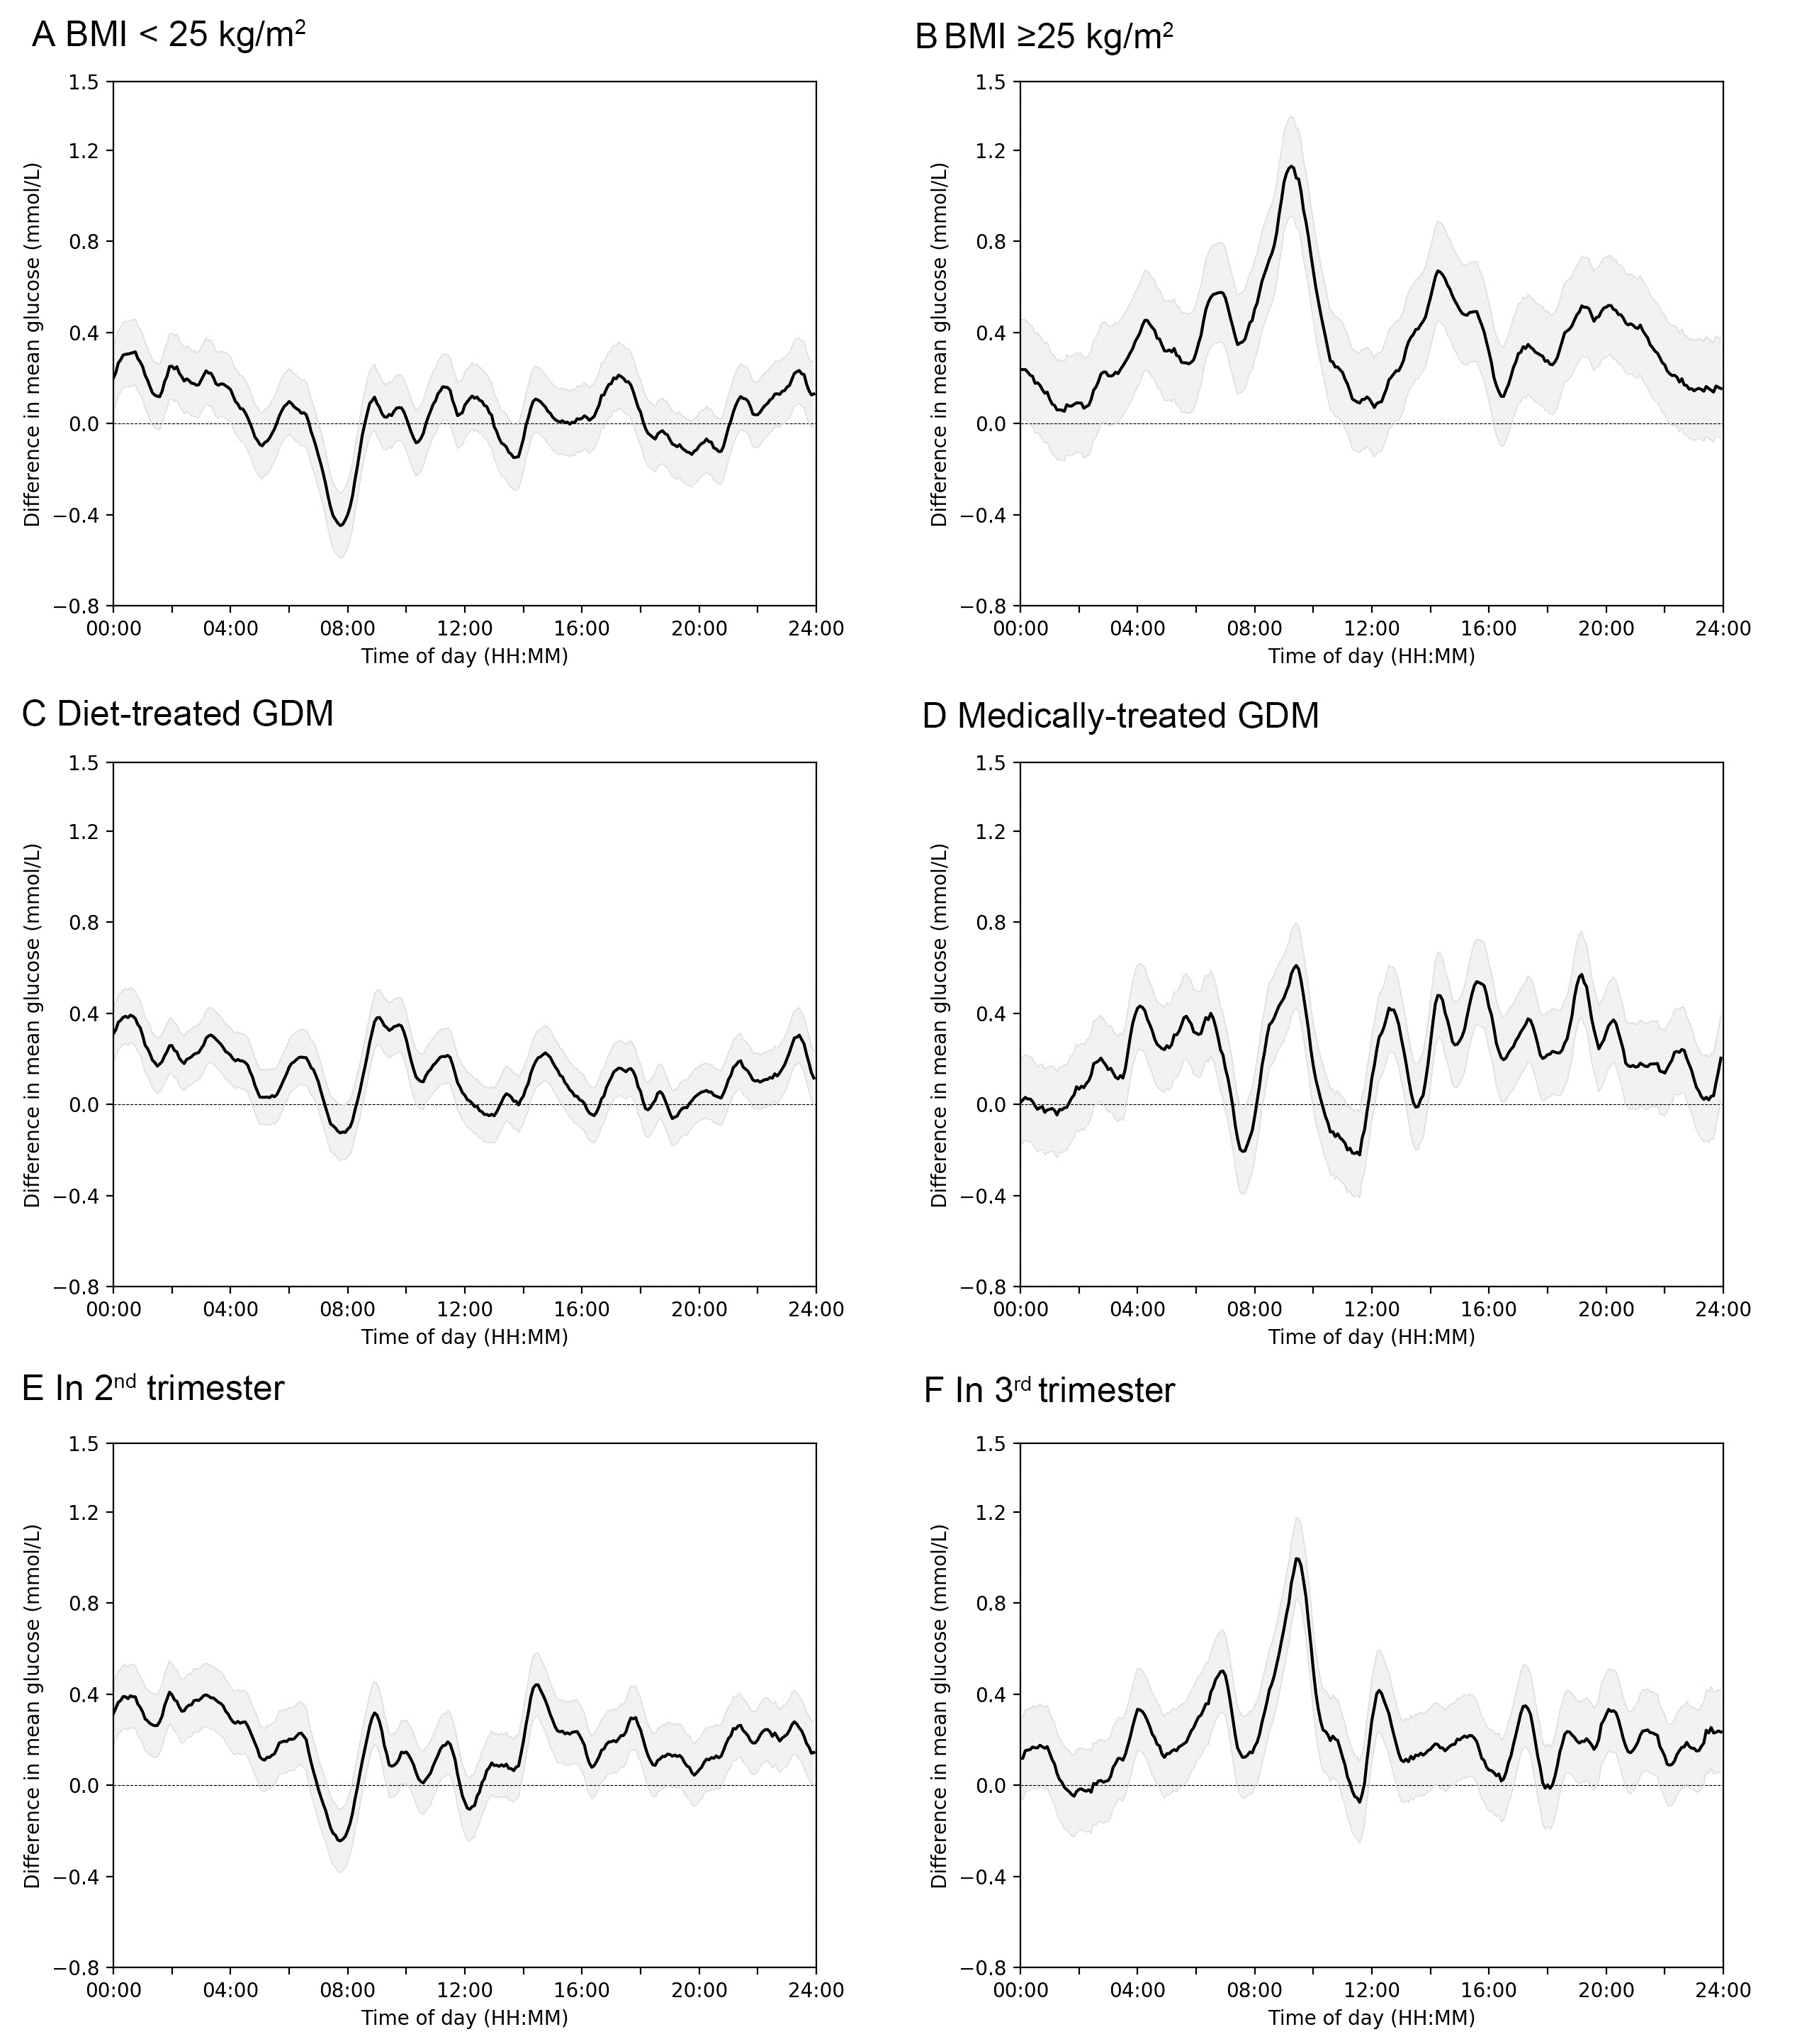

**Figure S4 Heatmaps and feature maps**

**A** Non-LGA

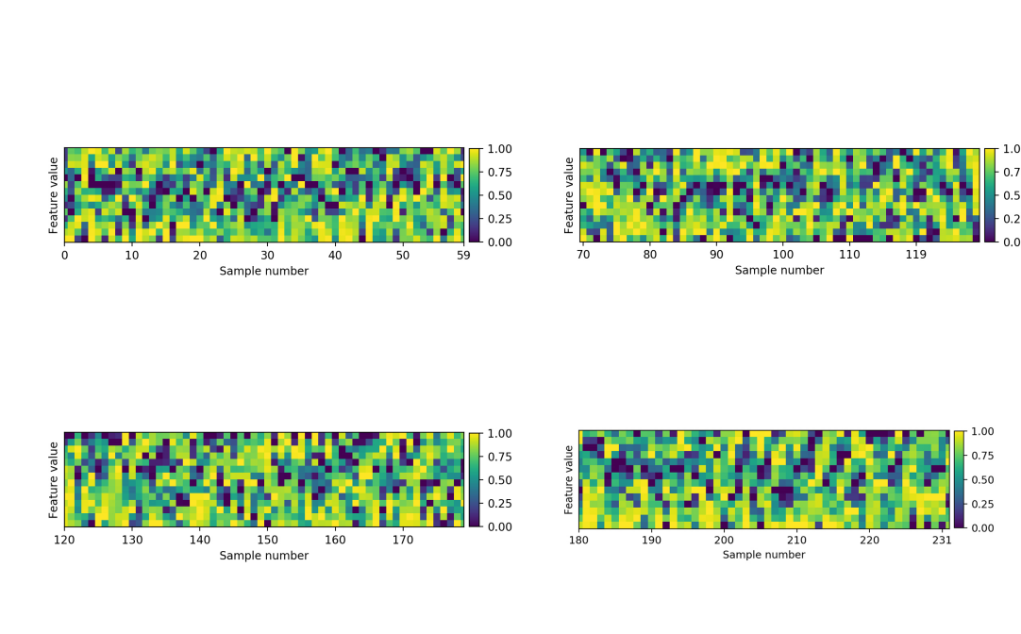

**B** LGA

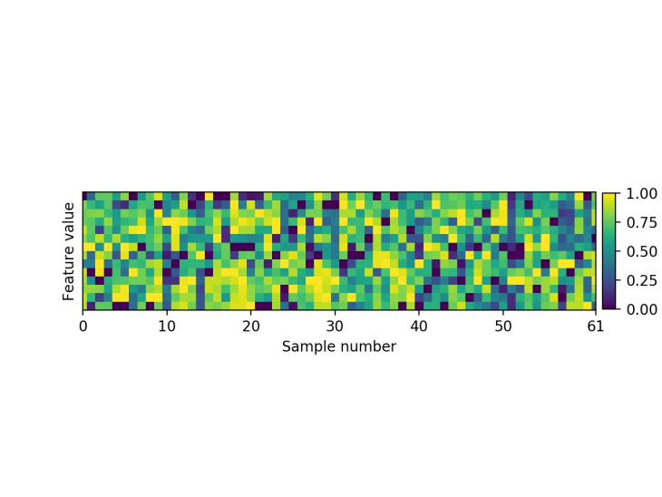

**C** Mean value of heatmap **D** Mean value of normalized heatmap

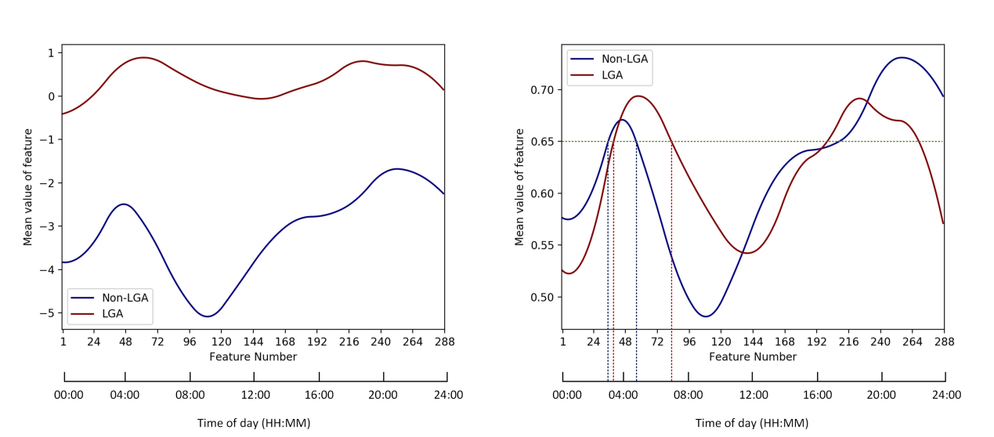

Notes: Figure S4.A presented feature values for a single case using the Class Activation Mapping (CAM) method from the final convolution layer of the Convolutional Neural Network (CNN) in the Non-LGA group. Similarly, the LGA group was illustrated in Figure S4.B. To evaluate the model's effectiveness, we plotted the mean values of feature values from all cases in the training dataset within 24 hours in Figure S4.C. The distinct difference between the two groups highlighted the model's proficiency in distinguishing between Non-LGA and LGA. In Figure S4.D, we analyzed the feature value distribution from another perspective by applying normalization and mean operations. A blue dashed line was introduced as a reference threshold to clearly illustrate the shift phenomenon.

**References**

1. Mao Anqi, Mehryar Mohri, Yutao Zhong. Cross-entropy loss functions: Theoretical analysis and applications. In International conference on Machine learning, pp. 23803-23828. PMLR, 2023.

[2] Parmar Aakash, Rakesh Katariya, Vatsal Patel. A review on random forest: An ensemble classifier. In International conference on intelligent data communication technologies and internet of things (ICICI) 2018, pp. 758-763. Springer International Publishing, 2019.

[3] Priyanka Kumar D. Decision tree classifier: a detailed survey. International Journal of Information and Decision Sciences. 2020;**12**(3):246-69

[4] Zhou Bolei, Aditya Khosla, Agata Lapedriza, Aude Oliva, Antonio Torralba. Learning deep features for discriminative localization. In Proceedings of the IEEE conference on computer vision and pattern recognition, pp. 2921-2929. 2016